Multispectral Images to Support Research

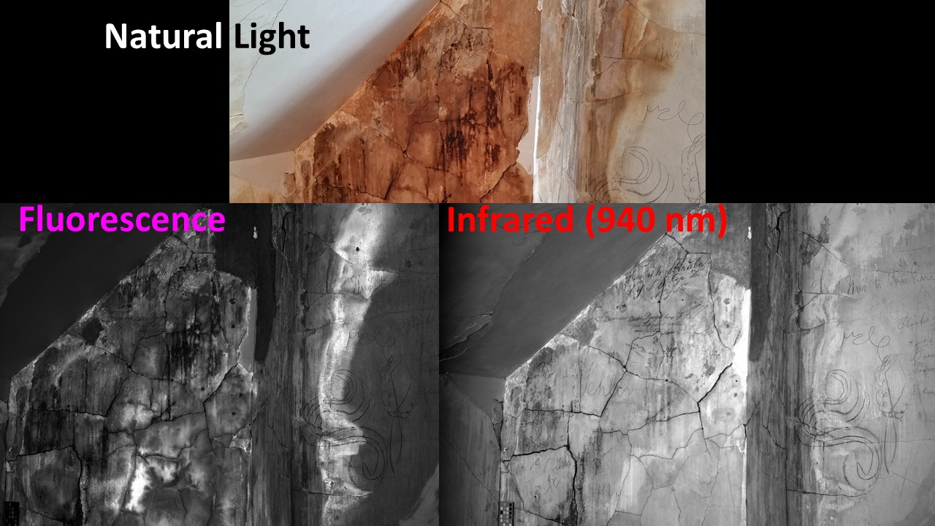

In Historic Blenheim images, UV fluorescence images may best support conservation of the walls by revealing wall materials and changes of significance. IR images may best support research into the graffiti itself by revealing the carbon-based graffiti and suppressing the wall materials.
In general terms, the 10 visible light wavelengths replicate what the human eye sees in natural light. The UV and blue light may offer better resolution, but most importantly may cause some materials to fluoresce, or illuminate in longer wavelengths. The longer IR wavelengths will penetrate some surfaces and reveal more information.

Researching Multispectral Images
The stacks of multispectral images of about 100 areas of the Historic Blenheim walls each comprise about 21 images. These provide a significant amount of data for research and analysis. Different images provide different levels of information for different disciplines. The following offers some guidance in using these images.

File Formats
Files are provided in 3 formats:
- TIFF still image files, ending in 'tif', of archival quality and without compression.
- JPEG still image files ending in 'jpg', most of these are unsuitable for archiving and significantly compressed into very small thumbnails. Processed images are also stored as jpegs, with some compression.
- AVI or GIF moving image files ending in ‘avi’ or ‘gif’
The tiff files have the highest resolution and will reveal the most details in an image. They are large and take more time to open, so the jpeg thumbnails may be quicker to use to first locate a specific image. The moving image files may offer similar quicker insights into a range of digitally processed images. The processed images are saved as jpeg images with smaller size for ease of access and sharing.
Thumbnail and jpeg processed images and some compressed jpeg representative captured images are hosted on an interim basis on Google Drive at https://drive.google.com/drive/folders/1TDDHRCbKGJzC7HeZcauZ4L1dt5-Cfdfr?usp=sharing

Multispectral Images
Multispectral images were captured in shorter wavelength ultraviolet (UV), visible wavelengths of light and longer wavelength infrared (IR) light, as well as with filters to collect fluorescence emissions (below). In general terms, the 10 visible light wavelengths replicate what the human eye sees in natural light. The shorter wavelengths in the UV and blue may offer better resolution, but most importantly they may cause some materials to fluoresce, or emit energy in longer wavelengths. This very faint longer wavelength fluorescing light, sometimes pink or orange, will pass through the filters that block the reflected UV or blue light. The longer wavelengths will penetrate surfaces and may reveal more information from within.
For Historic Blenheim imaging, this means that the UV fluorescence images frequently better reveal wall materials and changes of significance to conservation of the walls. IR images frequently better reveal the carbon-based graffiti and suppress the wall materials, which may better support research into the graffiti itself.
Each image filename details the sixteen illumination types and the filters:
Illumination Numbers
- 365 - 365 nm UV LED illumination
- 385 - 385 nm UV LED illumination
- 410 - 410 nm borderline UV-visible LED illumination
- 420 - 420 nm visible LED illumination
- 450 - 450 nm visible LED illumination
- 480 - 480 nm visible LED illumination
- 510 - 510 nm visible LED illumination
- 530 - 530 nm visible LED illumination
- 550 - 550 nm visible LED illumination
- 600 - 600 nm visible LED illumination
- 620 - 620 nm visible LED illumination
- 635 - 635 nm visible LED illumination
- 650 - 650 nm visible LED illumination
- 740 - 740 nm LED IR illumination
- 850 - 850 nm LED IR illumination
- 940 - 940 nm LED IR illumination
- 000 - No illumination, (dark image) capturing ambient light only
Filter Symbols
- N = CLEAR (no filter)
- G = LP515 (long pass filter that passes wavelengths longer than 515 nm - green and above)
- R = LP515 (long pass filter that passes wavelengths longer than 590 nm - red and above)
- U = BP365 (UV bandpass filter, not used at Blenheim)
- V = LP400 (long pass filter that passes wavelengths longer than 400 nm - blue and above, not used at Blenheim)
- I = LP715 (long pass filter that passes wavelengths longer than 715 nm - IR and above, not used at Blenheim)

Captured Images
Captured Image data consists of TIFF images. These are individual images from each of the imaging systems taken with different energy levels of light. Each has a standardized name with metadata for each image entered into the TIFF header and an associated json file (a standard data interchange format that can be read as a text file).
Examples for captured images are:
Project_Scene-Stack-<wavelength and filter>_<index number>_R.tif
For the “Blenheim” NCPTT project, this yields:
Blenheim_Room-ROI-<wavelength and filter>_<index number>_R.tif
A representative image in the front parlor (Room 101) of the wall (Wall A) to the left of the fireplace (Section 1), in an area to the top left (area a), taken with 940 nm (IR) lights with no filter, which is the 14th shot, yielding:
Blenheim_Rm101-A1a-940N_014_R.tif
A stack of reflected images captured at different wavelengths of light and fluorescence images captured with different wavelengths and filters yields a folder containing the following 21 captured image files and the json metadata file:

Blenheim_Rm101-A1a.json
Blenheim_Rm101-A1a-410N_001_R.tif
Blenheim_Rm101-A1a-420N_002_R.tif
Blenheim_Rm101-A1a-450N_003_R.tif
Blenheim_Rm101-A1a-480N_004_R.tif
Blenheim_Rm101-A1a-510N_005_R.tif
Blenheim_Rm101-A1a-530N_006_R.tif
Blenheim_Rm101-A1a-550N_007_R.tif
Blenheim_Rm101-A1a-600N_008_R.tif
Blenheim_Rm101-A1a-620N_009_R.tif
Blenheim_Rm101-A1a-635N_010_R.tif
Blenheim_Rm101-A1a-650N_011_R.tif
Blenheim_Rm101-A1a-740N_012_R.tif
Blenheim_Rm101-A1a-850N_013_R.tif
Blenheim_Rm101-A1a-940N_014_R.tif
Blenheim_Rm101-A1a-365G_016_R.tif
Blenheim_Rm101-A1a-365N_015_R.tif
Blenheim_Rm101-A1a-385G_017_R.tif
Blenheim_Rm101-A1a-410G_018_R.tif
Blenheim_Rm101-A1a-365R_019_R.tif
Blenheim_Rm101-A1a-410R_020_R.tif
Blenheim_Rm101-A1a-000N_021_R.tif

Some areas were reimaged to adjust lighting or due to a technical or other issue. Reimaging of the same section is designated with the suffix “k” and subsequent letters for subsequent reimaging. Images taken at a distance or oblique angle are designated with the suffix “z”.
Corners formed by two walls have both walls in the filename, e.g. Entry hall back right corner is A3B1. Two sections of a wall are designated with the Wall designation and numbers of both sections, e.g. Attic 301-A1A2.
The folder “RBTothAssocTest 2019” includes the original 13 test image stacks from the 2019 pro bono imaging by R.B. Toth Associates. The folders have been renamed to conform to the spatial naming convention subsequently used for the rest of the imaging. The folder “Thumbnails” contains very small thumbnail images of poor image quality for reference only, and are not archival images. The .tif images are the only images with sufficient 350-450 ppi quality for future research and archiving.

Computer Processed Images
Images that have been digitally produced through the application of computer algorithms to combine and enhance captured images to enhance visibility of manuscripts artifacts and text. All processed images are TIFF or jpeg images, or AVI video clips of a series of processed images.
Principal components analysis (PCA) is a numerical technique for identifying which illumination wavelengths and combinations offer combinations of captured images to help identify and distinguish unique features in image stacks. This can aid visual recognition of faint content that would otherwise be undetected. PCA was used in this study to create monochrome and false color “pseudocolor” output images that provide additional insight into features on the Interior walls.
Processed images amend the naming convention to indicate the type of processing employed and refer to the index number of a component image. A filename for the captured image stack above exemplifies the naming practices used for processed images:
Blenheim_Attic301-A3a_N_PCA--pc01-pc02-pc03-pc05_PCAN-1--3_RGB.jpg
Project name: Blenheim
Scene name: Attic301
Stack name: A3a
Processing: 1. Principal Components Analysis (PCA) Normalized
2. PCA components 01, 02, 03 and 05 were used in the R, G, and B channels, respectively, of the final (synthetic) RGB jpg image

Metadata
Each multispectral capture image folder is provided with descriptive metadata in the JSON file giving details of the image capture for the project, scene and stack of images and processing methods used to generate integrated images from the various captured images. Metadata includes the following metadata elements at the “Project” and “Scene” level, with technical collection details included at the “Stack” level, including more description of the area imaged.

File Names
A spatial standard was established to accurately designate location of regions on the Historic Blenheim walls. Historic Blenheim is not aligned to cardinal compass points, so a lettering and numbering system was used to designate image locations.

Rooms
Three digit room numbers from the architectural plans were used, e.g. Left Front Parlor is Room 101, etc. (Attic 301 and Room 302 were used for the two attic rooms.)

Walls
Interior walls of each room were assigned letters in a clockwise fashion facing into the house from the front door:
- Left Wall: A,
- Back (facing) Wall: B
- Right Wall: C
- Front (entry) Wall: D

Regions
Broad areas on each wall were divided by numbers from left to right facing the wall, usually with wall features serving to differentiate the region, e.g. in Room 101 fireplace wall the area to the left of the fireplace is Region 1, over the fireplace Region 2, and right of the fireplace Region 3. Regions were further subdivided with lower case letters starting with the letter ‘a’ from left to right, e.g. first region to the left is ‘a’, region to the right is ‘b’, etc. They were divided vertically with numbers from 1 at the top, e.g. top region is 1, next down is 2, etc.

Rights
All images from are licensed Creative Commons 0 (CC0) for free access and sharing without having to request permission. We request processed images used in public display, media, publications or video imaging credit “R. B. Toth Associates”.

